DASHBOARD DESIGN
Field | Details
Date | 20-Aug-2026 TO 22-Aug-2026
Team ID | Individual
Project Name | Food Delivery Analytics: Customer Behaviour & Operational Insights
Maximum Marks | 5 Marks

Activity 1: Interactive and Visually Appealing Dashboard
The Food Delivery Analytics: Customer Behaviour & Operational Insights Tableau dashboard is designed to provide an interactive analysis of food orders, customer behaviour, cuisine preferences, revenue, city-level demand, meal types, delivery performance, and customer satisfaction.
Dashboard Design Principle | Implementation in My Tableau Dashboard
Clear and Intuitive Layout | KPI cards are placed at the top, followed by visualizations for customer behaviour, cuisine preferences, revenue, city performance, and delivery operations.
Use Appropriate Visualizations | KPI cards, horizontal bar charts, stacked bar charts, heatmaps, donut charts, treemaps, and histograms are used based on the type of analysis required.
Colour and Theming | A consistent dark theme with contrasting colours is used to distinguish categories and highlight important metrics..
Interactive Filters and Slicers | Filters for City, Cuisine, and Meal Type allow users to interactively explore different segments of the food delivery data.
Drill-Down Capabilities | Users can analyze performance from an overall level to detailed views by city, cuisine, meal type, company, age group, and restaurant type.
Responsive Design | Dashboard components are arranged into logical sections to maintain readability and make comparisons between visualizations easier.
Custom Visuals and Icons | KPI cards and customized charts highlight important business measures such as orders, revenue, delivery fees, order value, and customer ratings.
Use of Infographic | Visual charts and graphical elements transform complex food delivery data into simple and understandable business insights.
Major Outcomes from the Dashboard
1. Overall Food Ordering Performance
The KPI cards provide a quick summary of the business performance, showing Total Revenue of $27M, Average Order Value of 547.7, Repeat Order Rate of 49.97%, and Average Delivery Fee of 7.497. These KPIs provide a high-level view of revenue, customer spending, repeat behaviour, and delivery costs.
2. Revenue by Cuisine and Restaurant Type
The treemap compares revenue contribution across different cuisines and restaurant types such as Desserts, South Indian, Fast Food, Chinese, Biryani, and North Indian. It helps identify the cuisine and restaurant segments contributing strongly to revenue.
3. Repeat Orders by Customer Mood
The 100% stacked bar chart compares repeat-order behaviour across different moods, including Celebrating, Happy, Lazy, and Stressed. The visualization shows that repeat-order percentages are relatively balanced across moods, with both repeat and non-repeat orders contributing approximately half of the orders.
4. Operational Bottlenecks: Order Volume vs. Delivery Time
The combined bar and line chart compares order volume with delivery time. It helps identify whether higher order volumes are associated with longer delivery times and highlights potential operational bottlenecks.
5. Weekday vs. Weekend Orders by City
The stacked bar chart compares weekday and weekend orders across Bangalore, Chandigarh, Delhi, Hyderabad, Mumbai, and Pune. This helps understand city-level ordering patterns and differences between weekday and weekend demand.
6. Rain's Impact on Delivery Time
The distribution chart compares delivery time under different rain conditions. It helps investigate whether weather conditions are associated with changes in delivery performance.
7. Rain's Impact on Delivery Fees
The same operational visualization also compares delivery fees under rain conditions, helping assess whether adverse weather is associated with changes in delivery charges.
8. City-level Demand Analysis
The city comparison section provides a view of ordering activity across major cities such as Bangalore, Chandigarh, Delhi, Hyderabad, Mumbai, and Pune. This helps stakeholders compare market demand and identify cities requiring greater operational or business attention.
9. Customer Behaviour Analysis
The dashboard combines Repeat Order %, Mood, and interactive filters to provide insight into customer ordering behaviour. This can help identify behavioural patterns that may be useful for customer retention and engagement strategies.
10. Interactive Decision Support
The dashboard provides interactive filters for City, Hunger Level, Repeat Order, and Meal Type. Users can select different combinations to investigate specific customer segments and understand how revenue, repeat ordering, delivery performance, and other metrics change.

DASHBOARD NO 1:

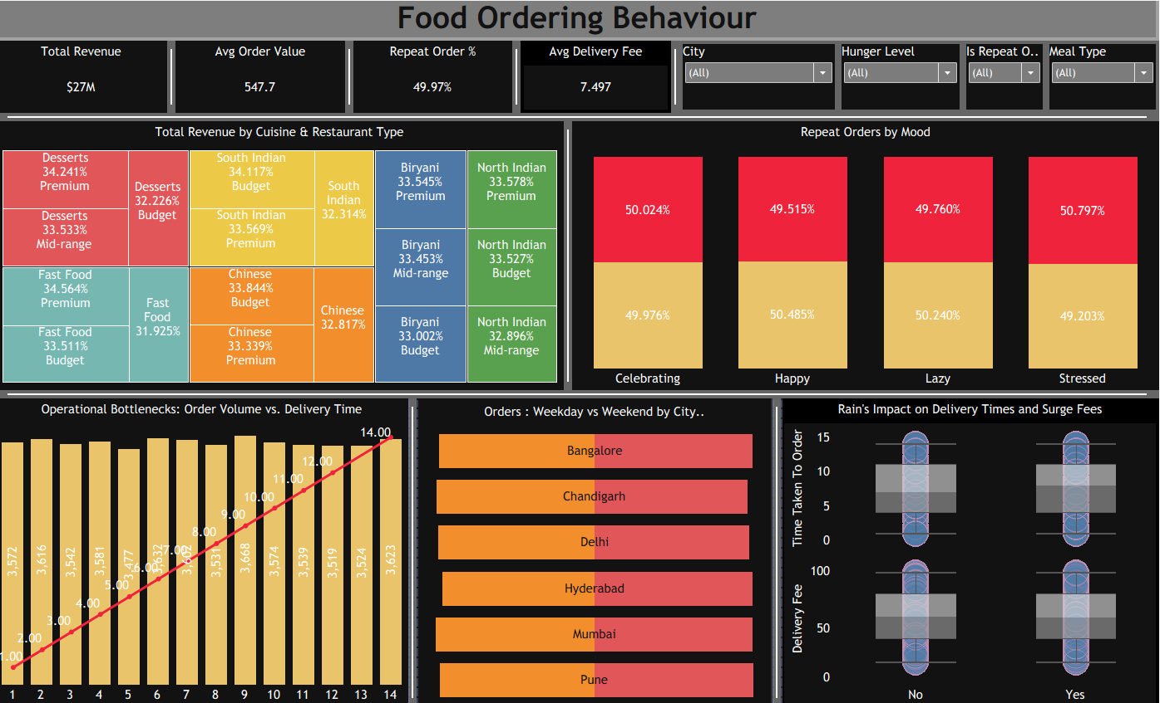

Tableau Public Dashboard Link:
https://public.tableau.com/app/profile/niranjan.patil7910/viz/FoodOrderingBehaviourN/FoodDelivery?publish=yes
Note: You need to publish your .twbx workbook to Tableau Public first and then paste the generated public URL in your project document.

